CENWP-OD-B 07 August 2023

MEMORANDUM FOR THE RECORD

SUBJECT: 23BON075 MFR WA Shore UMTJ RB1 Lamprey Mortality

On the afternoon of 05 August, FFU Biologists notified Project Biologists that a Pacific Lamprey mortality was discovered in the UMTJ RB#1 (Upstream Migrant Tunnel Junction) of the WA Shore LPS system. The fish was scanned for PIT tags and returned to the river.

- Species – Pacific Lamprey (Entosphenus tridentatus)
- Origin – Unknown
- Length – Approximately 63.5 cm
- Marks and tags – none
- Marks and Injuries found on carcass – none
- Cause and Time of Death –
- Future and Preventative Measures – none
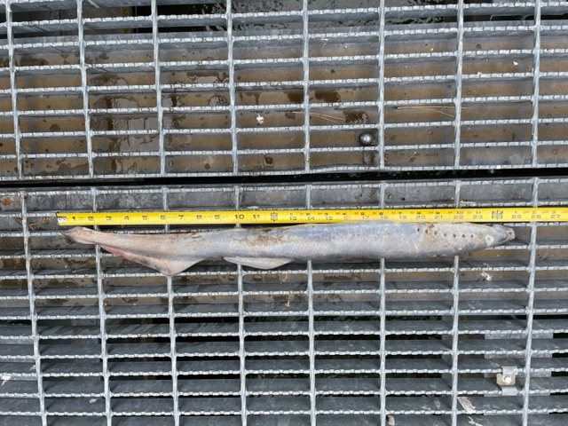

Sincerely,
Bonneville Project Fisheries

